

Probability and Statistics

**Name** – Ashish Gupta

**Roll No. -** DTU/2K16/MC/023

Department of Applied Mathematics

Delhi Technological University

**Programmed by IBM SPSS v21**

|  |  |  |  |
| --- | --- | --- | --- |
| **S.No.** | **Date** | **Topic** | **Signature**  **/remarks** |
| **1** |  | **Transportation of data from text and excel files into SPSS.** |  |
| **2** |  | **Entering of data in SPSS in variable view and data view.** |  |
| **3** |  | **Merging of data on the basis of cases and variables.** |  |
| **4** |  | **Splitting and filtering of data.** |  |
| **5** |  | **Write a program to find and replace missing values in data.** |  |
| **6** |  | **Pictorial representation of data.** |  |
|  |  |  |  |
|  |  |  |  |
|  |  |  |  |
|  |  |  |  |
|  |  |  |  |
|  |  |  |  |
|  |  |  |  |
|  |  |  |  |

**INDEX**

**Practical 1: Transporting dataset to SPSS editor**

**Inputs:** My_ExcelFile.xlss, textforspss.txt

**Procedure followed:** Through Excel

**Commands:** File > Open > Data

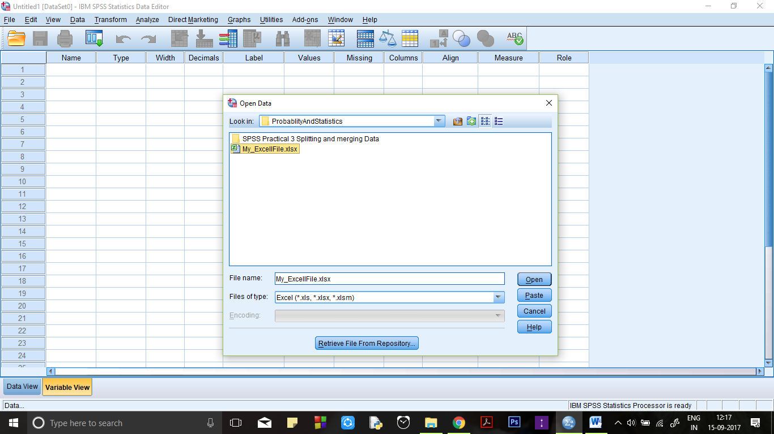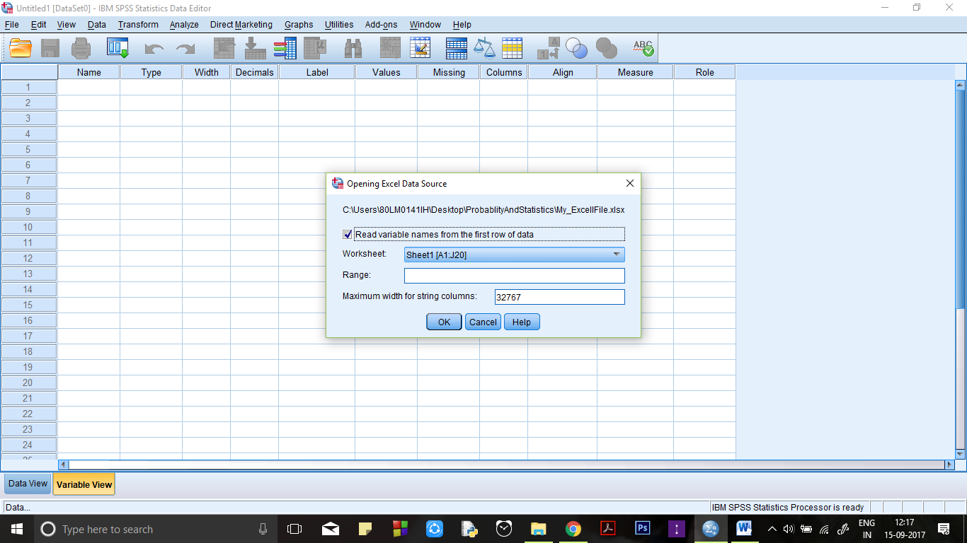

**Output**

**Variable View:**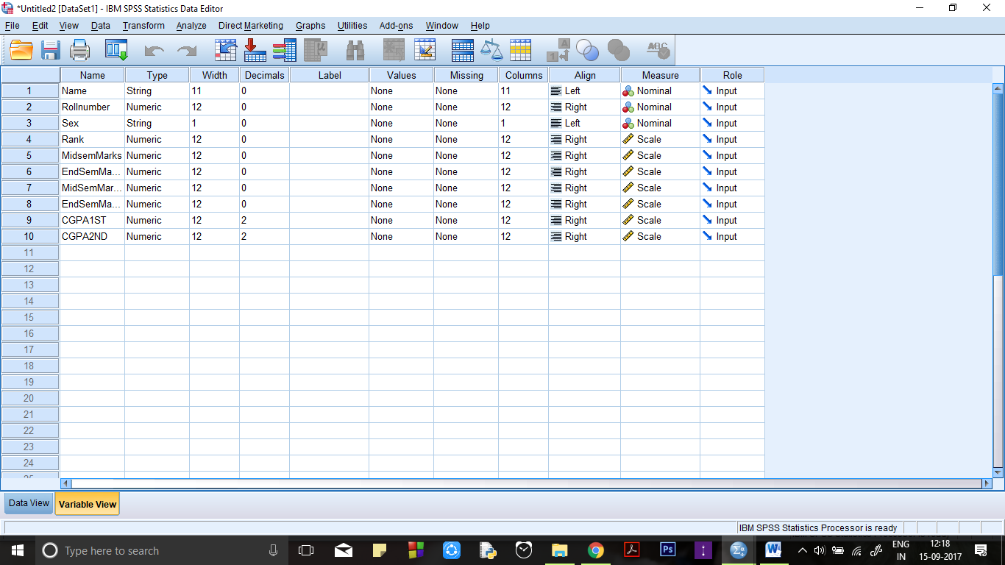

**Data View:**

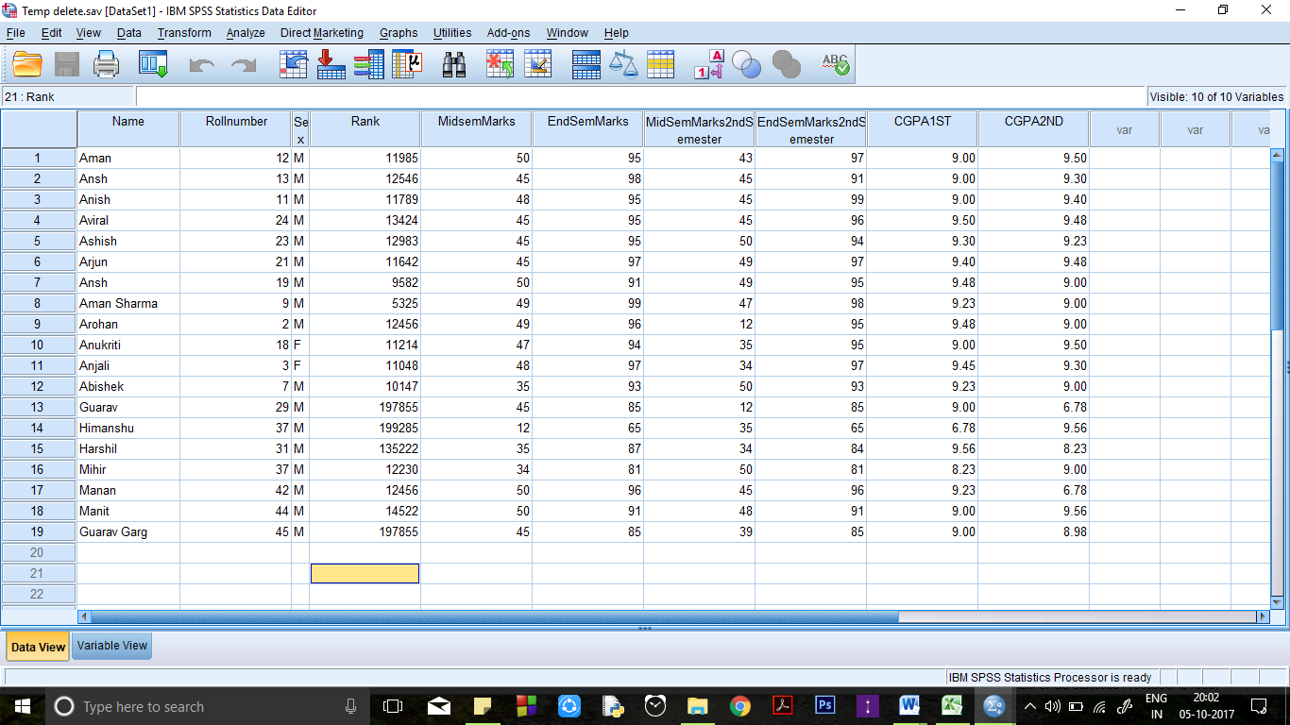

**Conclusion:**

Any document file in excel, text etc. formats can be transported to SPSS editor window.

**Precautions:**

There should be proper spacing between variables in a text in a file.

Extensions of the files should be strictly taken care of.

**Practical 2: Inputting Data in SPSS**

Inputs – Input data types at variable view.

Input full data in data view.

Commands - File -> open - > new

**Input File:**

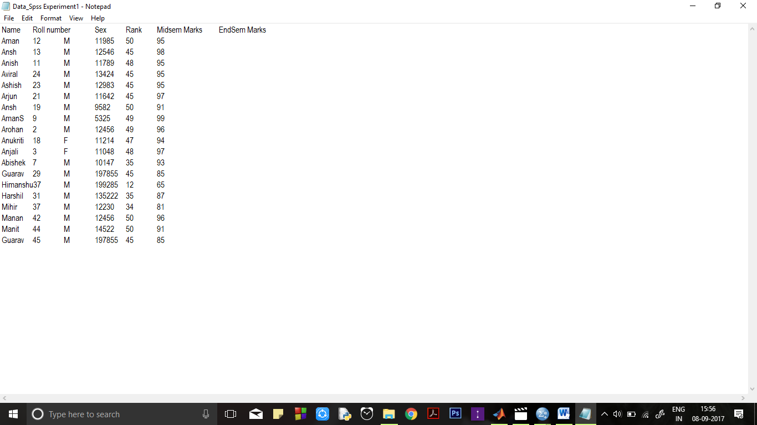

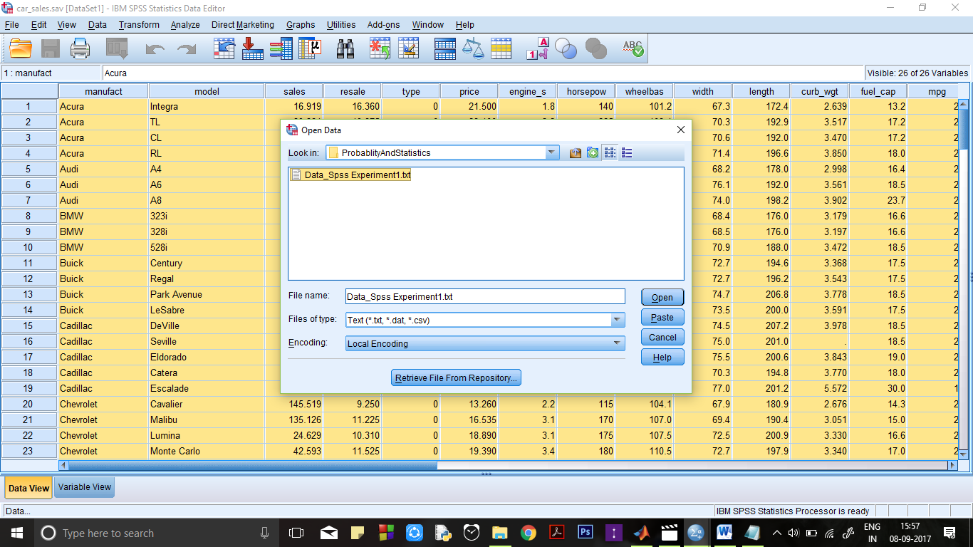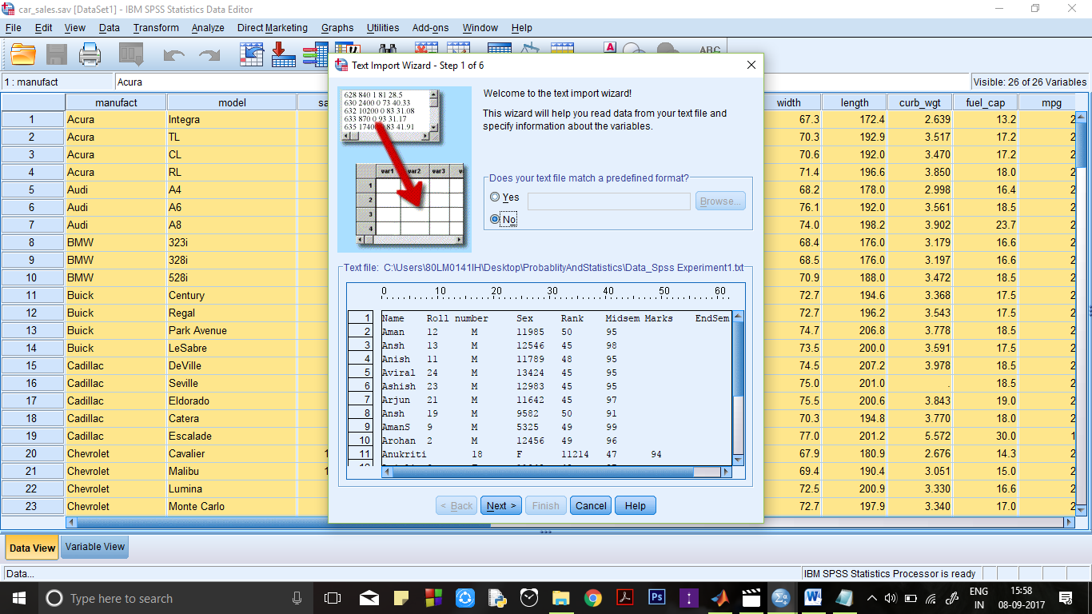

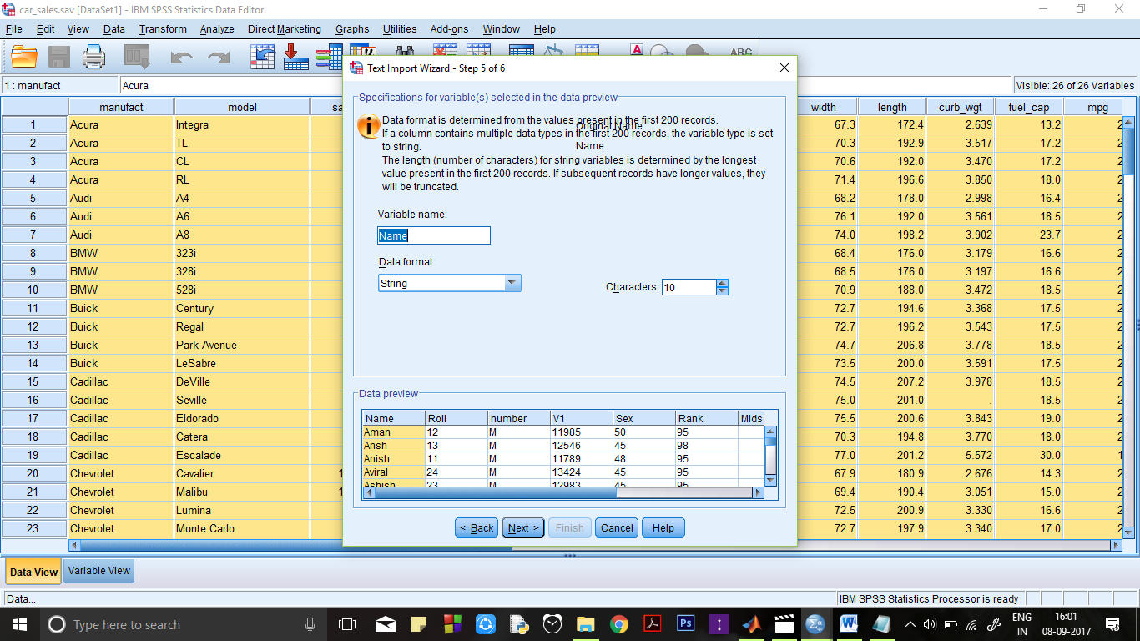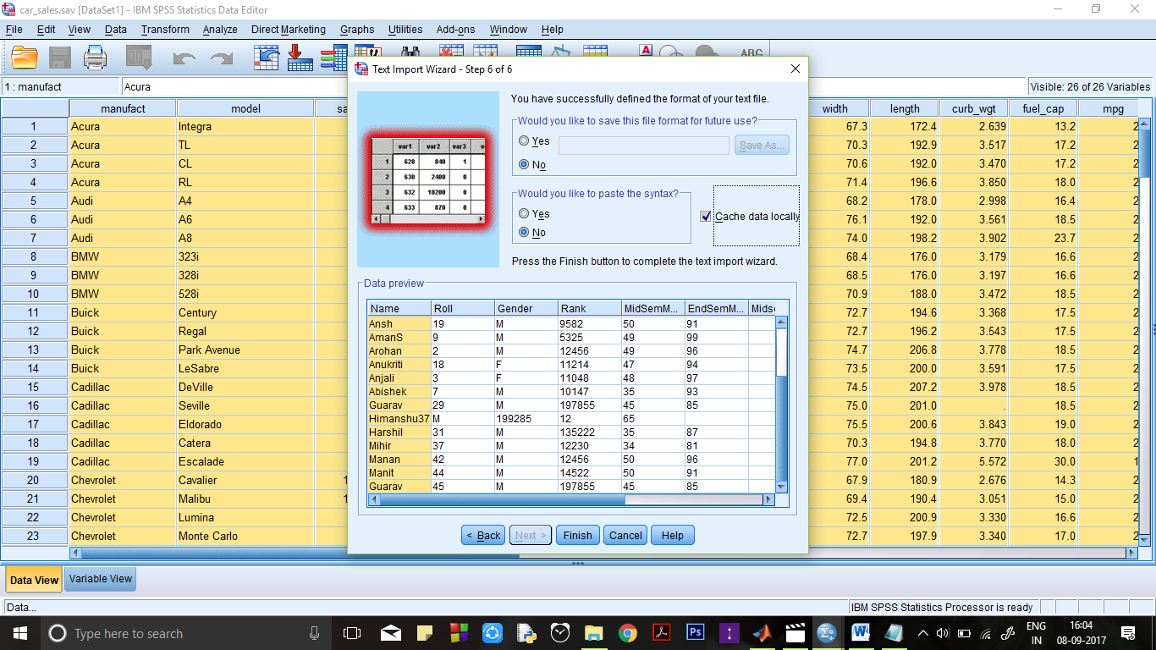

**Output:**

**Data View:**

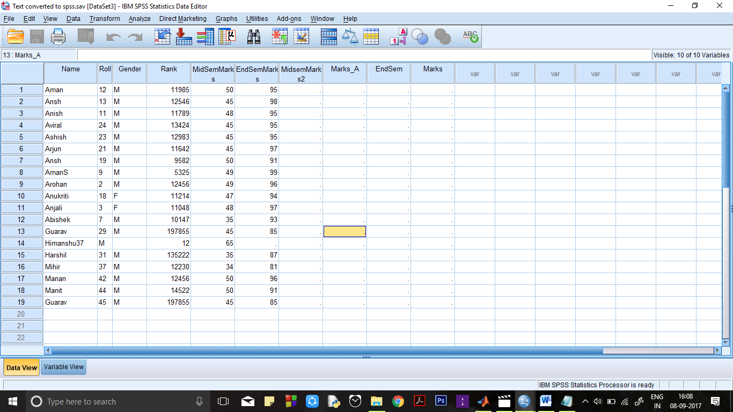

**Variable View:**



**Conclusion**:

A file can be made in spss by defining variables and their attributes and data can

be then entered and stored accordingly.

**Precautions**:

Attributes of a variable must be defined carefully keeping in view the requirement

of the variable.

Extensions of the files should be strictly taken care of.

**Practical 3: By using 4 files, Show :**

1. Merging of cases

2. Merging of variable value

a) Both files provide cases

b) Non active data set is keyed table

c) Active data set is keyed table

**Input** 4 files File1, File2, File3 and File 4 are created in SPSS in which the user defines the variables, their attributes and enters the data.

**Input1: File1**

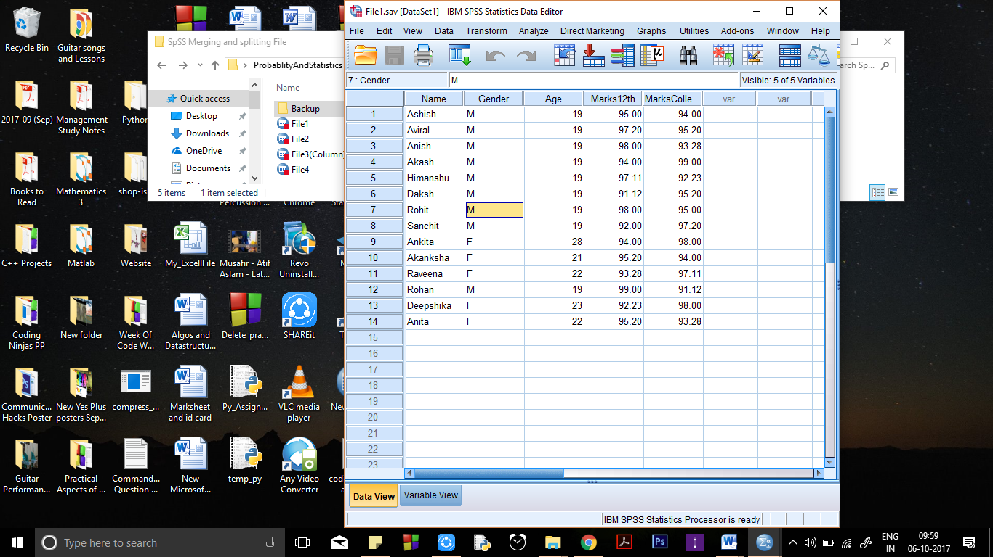

**Procedure:**

**Merging of Cases**: Open FILE1.sav - File > Open > Data

Data> Merge Cases > Add cases

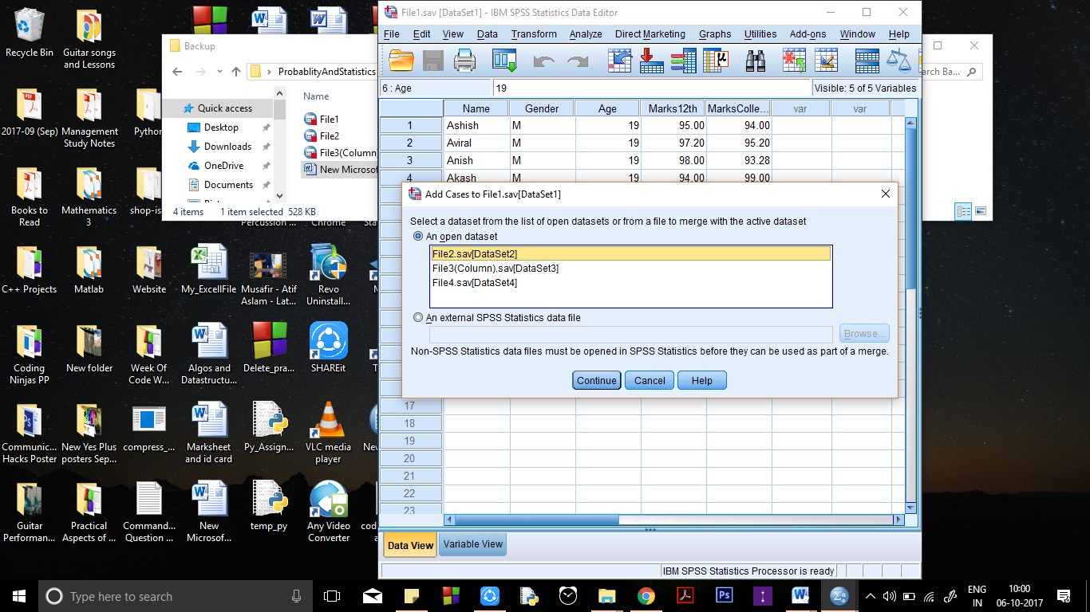

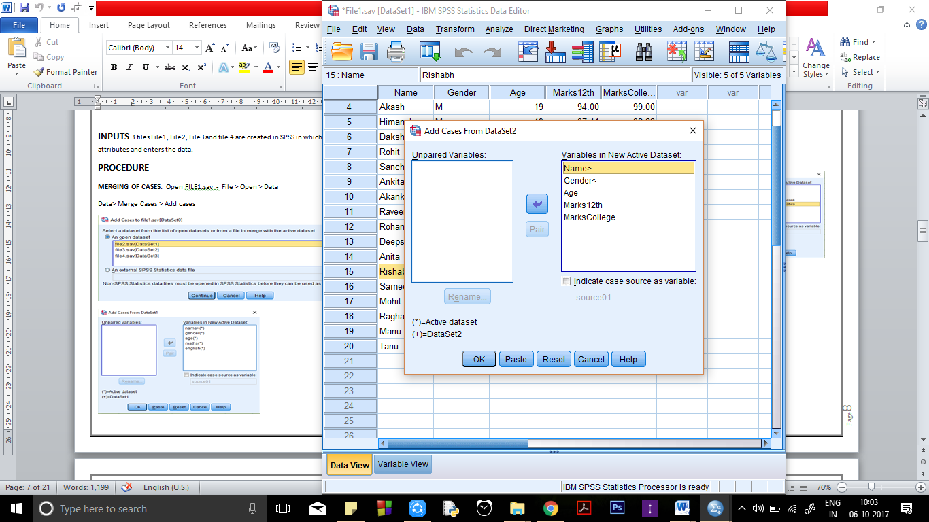

**OUTPUT: Merged data view of file1 and file2**

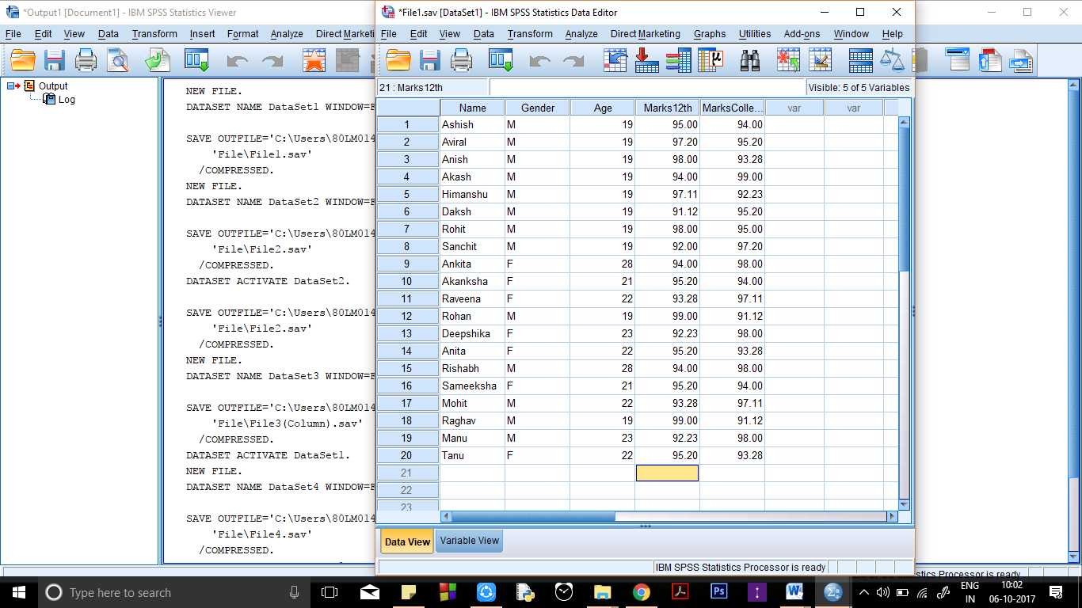

**MERGING OF CASES – when short form of other variable is written in another file**

Data> merge sort > cases

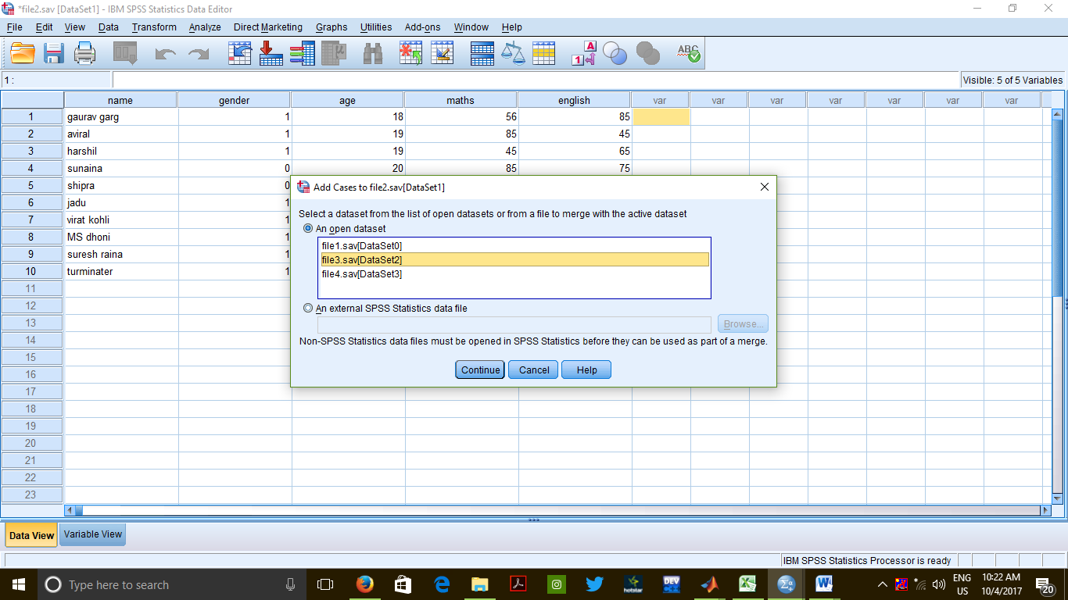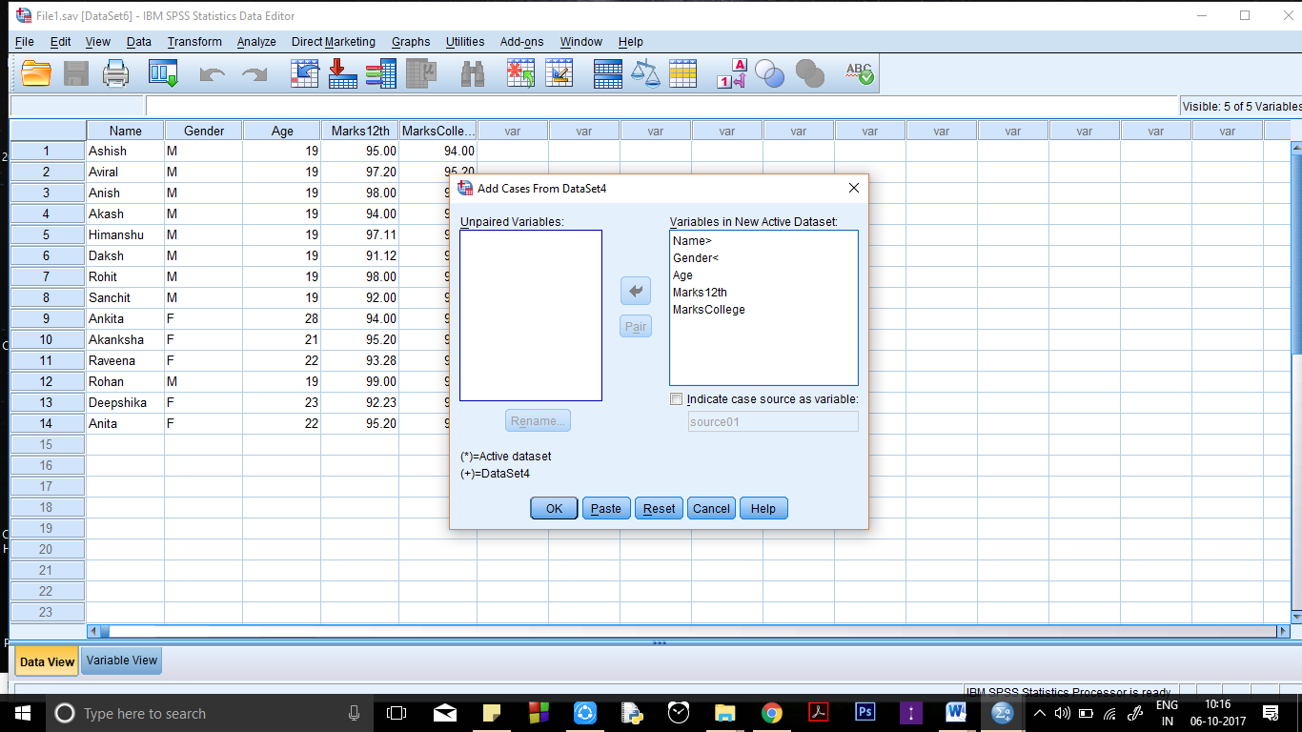

**OUTPUT**

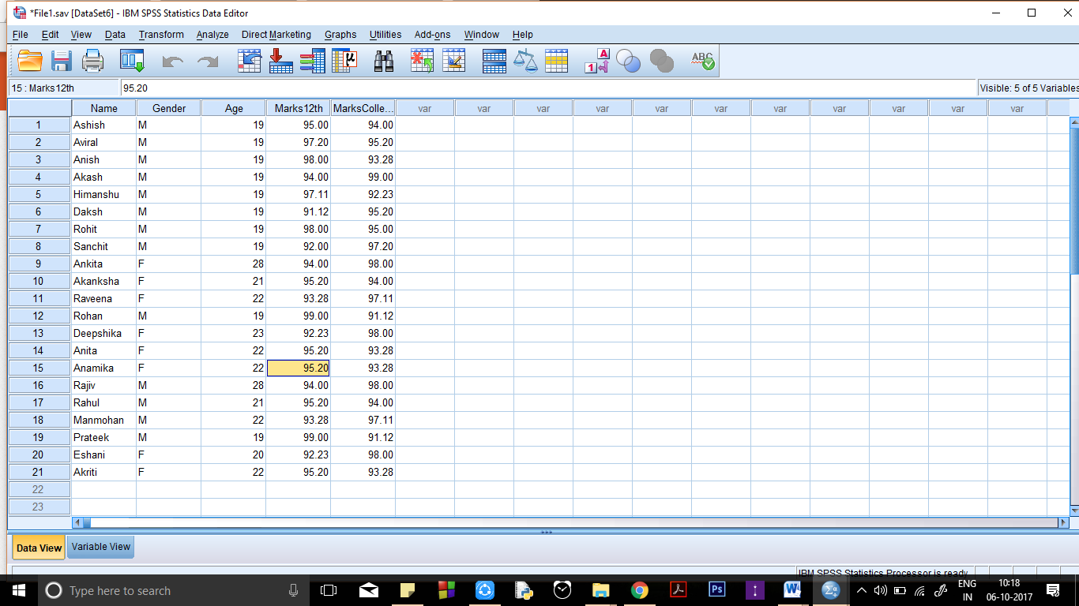

**Merging of Variable Values**

**Input:**

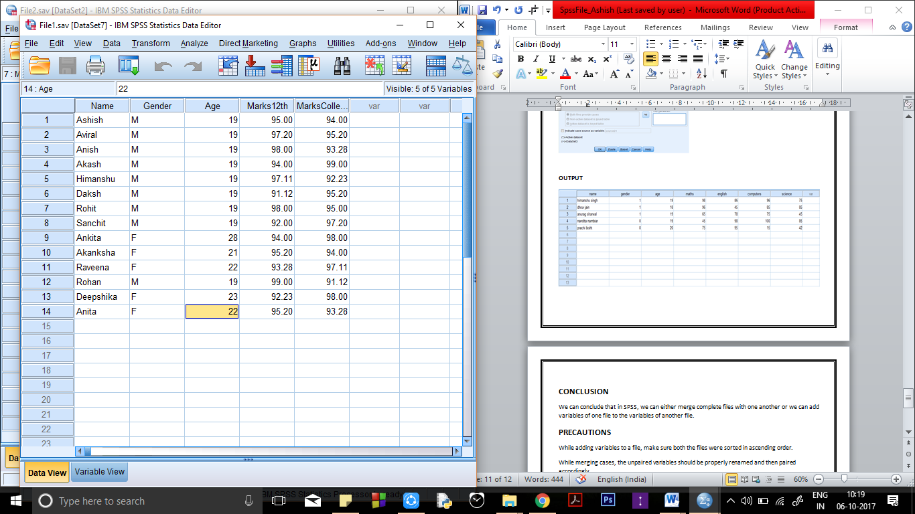

**Procedure:** Data> Merge Cases > Add variables

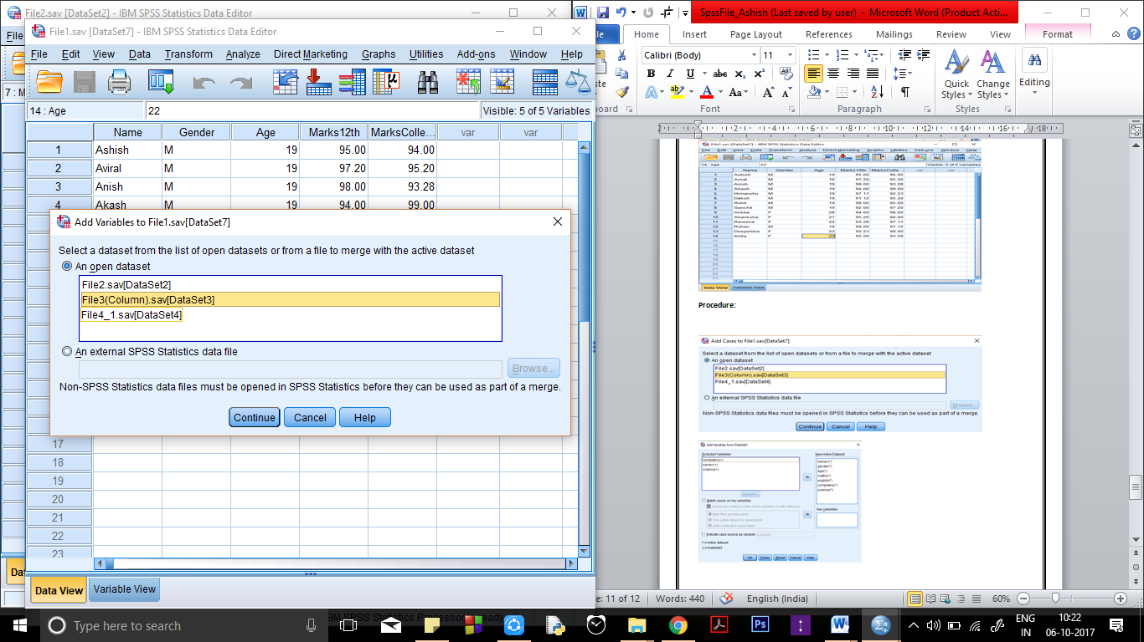

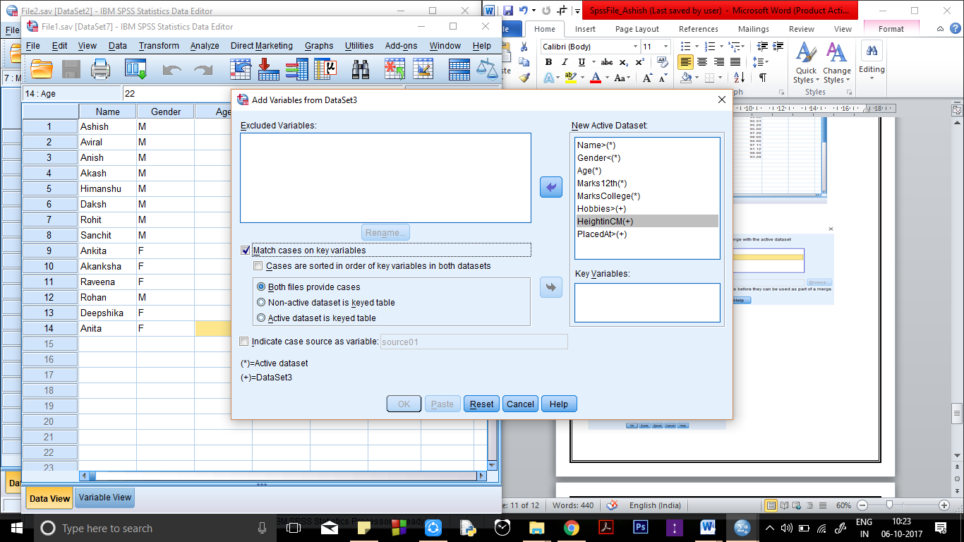

**OUTPUT**

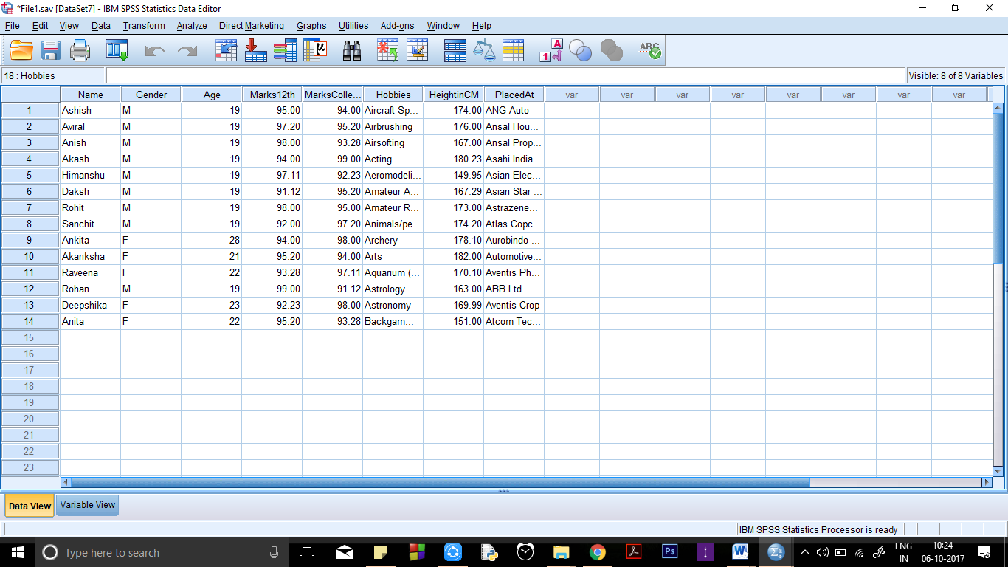

**CONCLUSION**

We can conclude that in SPSS, we can either merge complete files with one another or we can add variables of one file to the variables of another file.

**PRECAUTIONS**

While adding variables to a file, make sure both the files were sorted in ascending order.

While merging cases, the unpaired variables should be properly renamed and then paired accordingly.

**Practical 4:**

Demonstrate the following in a SPSS file

Filtering of Data

Splitting of File According to Variable(s)

**Filtering Of Data**

Open "File1" from the samples provided along with the software.

Data > Select Cases

Choose the button saying "If condition is satisfied".

Click on the "if" button.

Specify the condition in the dialog box that opens.

Click on "Continue".

Click on "OK".

**INPUT:**



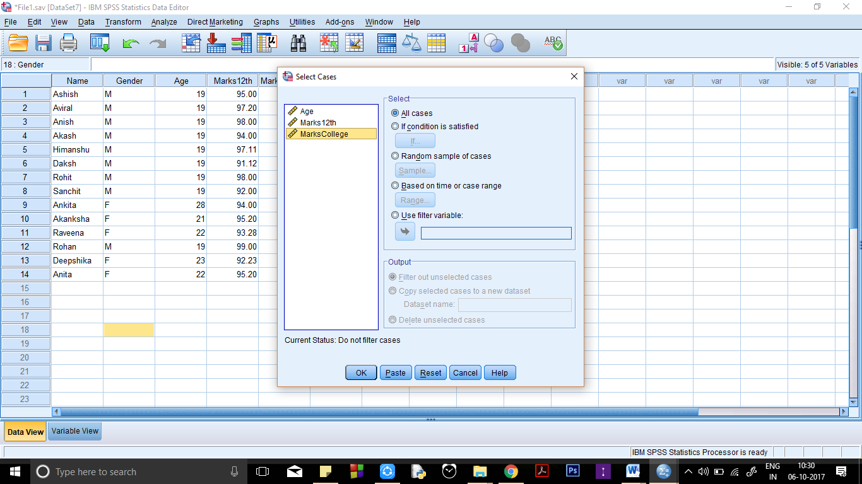

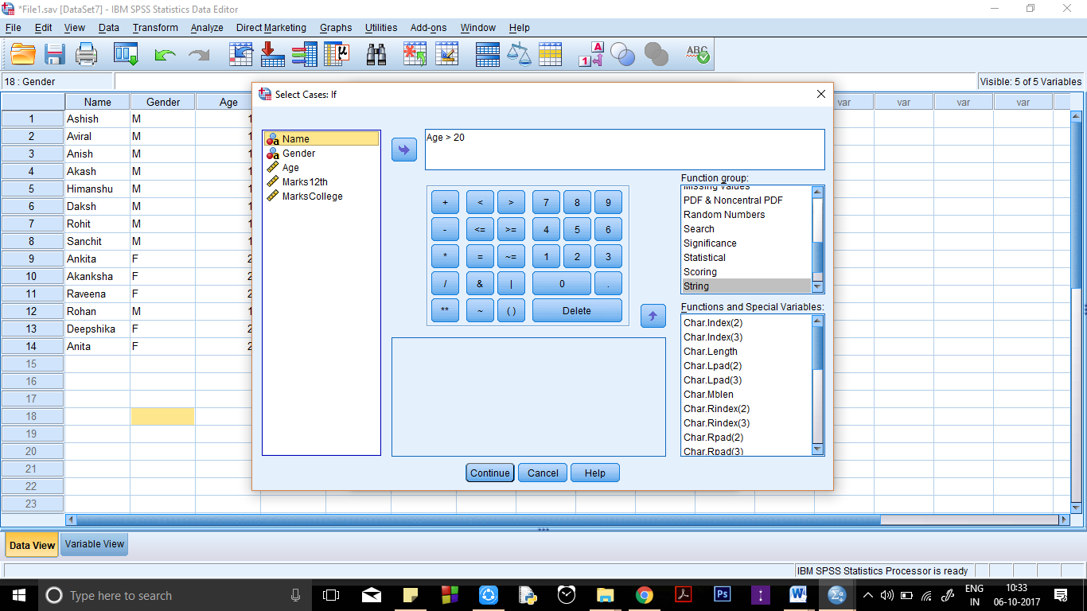

**Output:**

**Data View of File:**

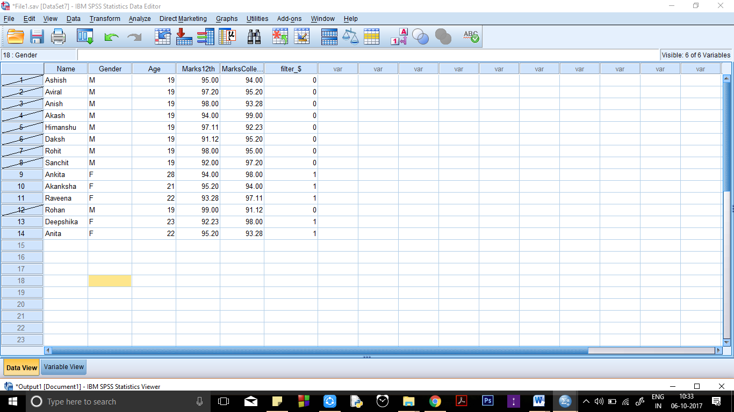

**Splitting of File According to Variable(s)**

File : "File1.sav"

Commands – file> data> split files

**Input & Procedure:**



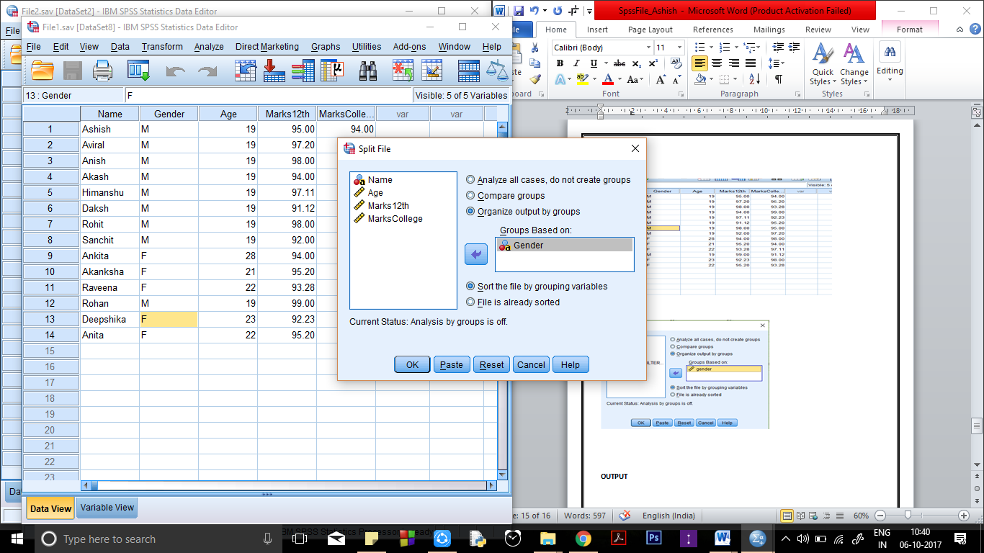

**OUTPUT**

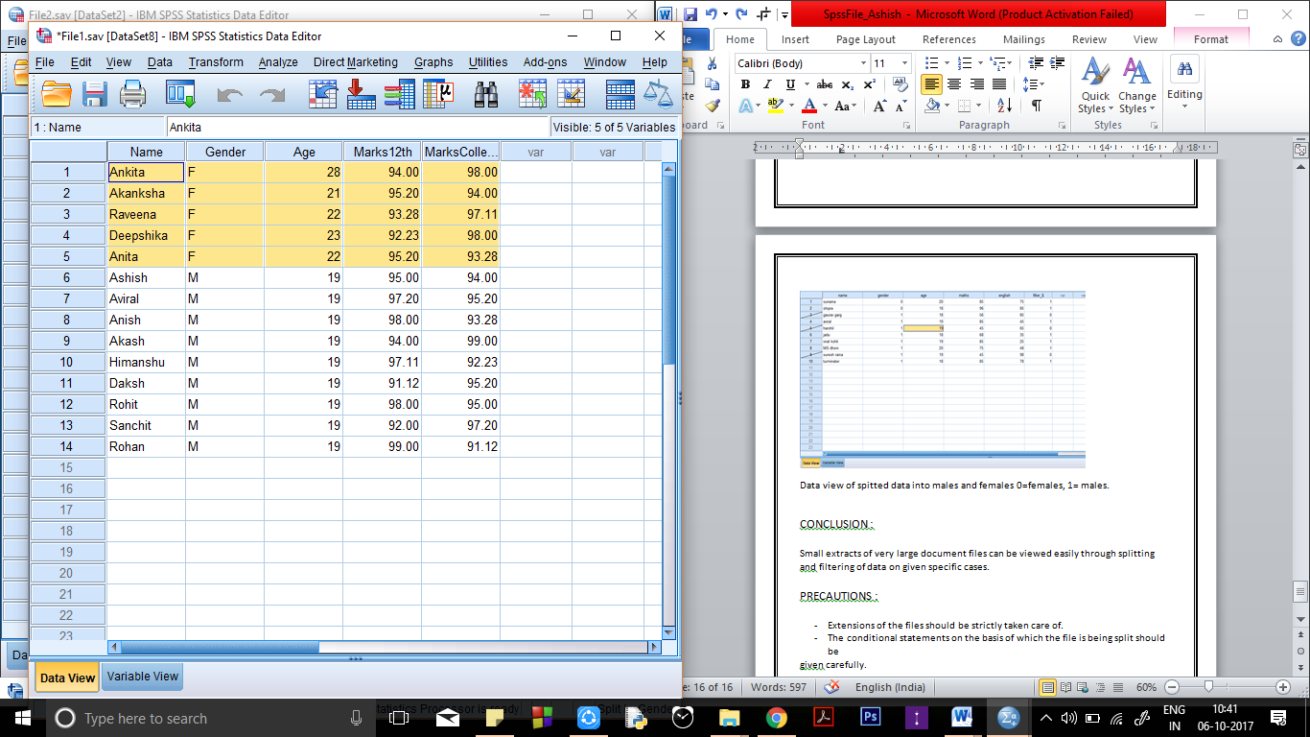

All F have been classified from M as seen in output.

**CONCLUSION**:

Small extracts of very large document files can be viewed easily through splitting

and filtering of data on given specific cases.

**PRECAUTIONS**:

Extensions of the files should be strictly taken care of.

The conditional statements on the basis of which the file is being split should be given carefully.

**Practical 5**

**Write a program to find and replace missing values in data.**

**INPUT:**

Car_Sales.sav

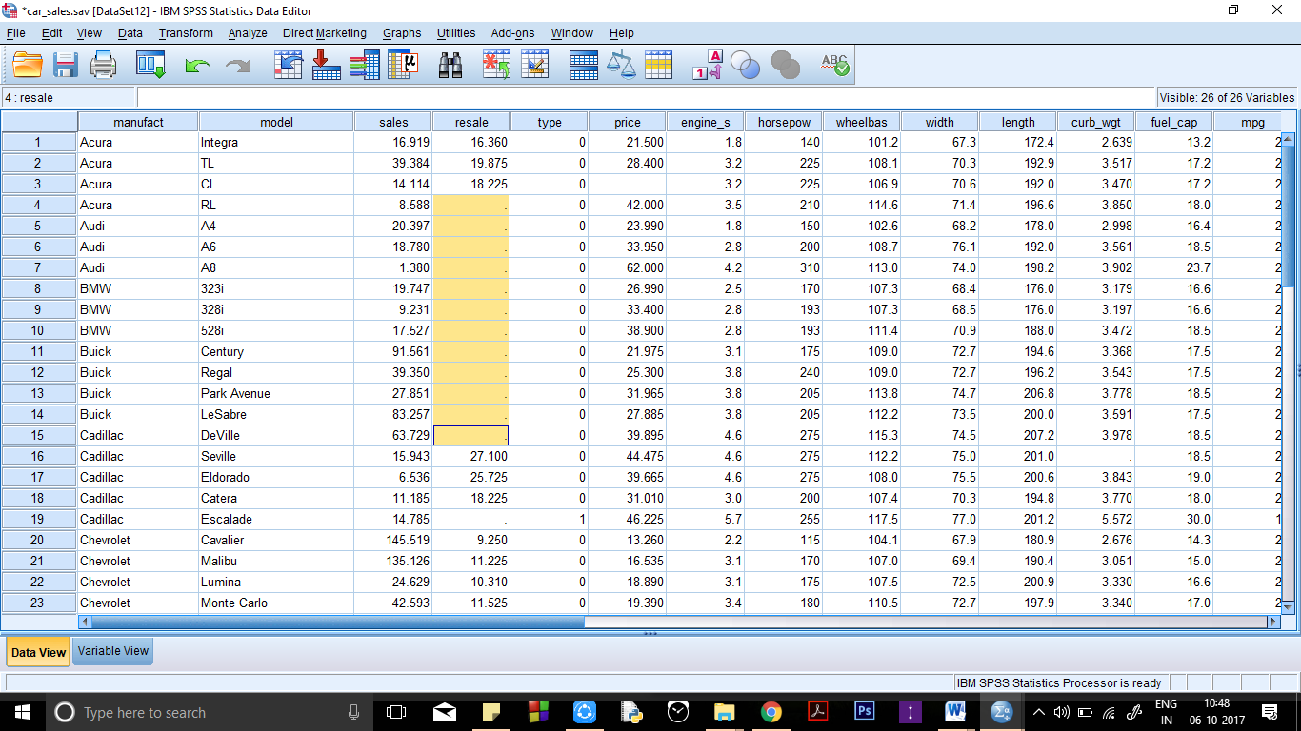

**Data view of carsales.sav while data in resale is missing(I have highlighted it)**

**PROCEDURE**:

1. Transform --> Replace Missing Values
2. Select the variable which contains missing values and add and rename it according to convenience and press the change button.

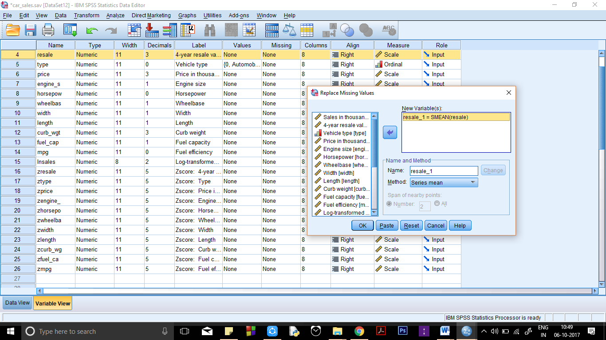

1. Than the value will be replaced as shown below

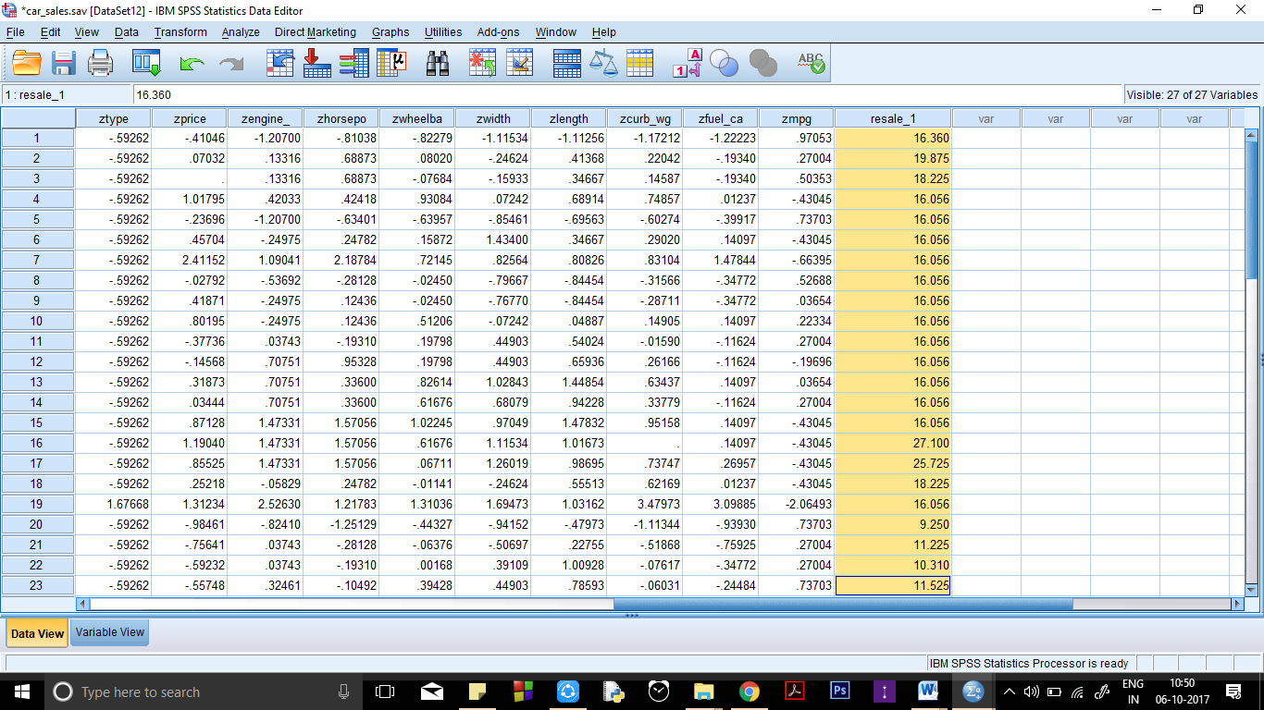

**Resale having missing value in new column resale_1**

**CONCLUSION**:

Missing values of certain fields is calculated by applying various methods like mean

of the complete data, mean of nearby data, median of nearby data, etc.

**PRECAUTIONS**:

1. The method of replacing missing variables must be carefully chosen.
2. Care must be taken while applying changes to a variable and applying changes to

the source variable itself must be avoided as future use of the source variable may

be present.

**Practical 6**

**Pictorial Representation of Data.**

**INPUTS**:

Car_Sales.sav

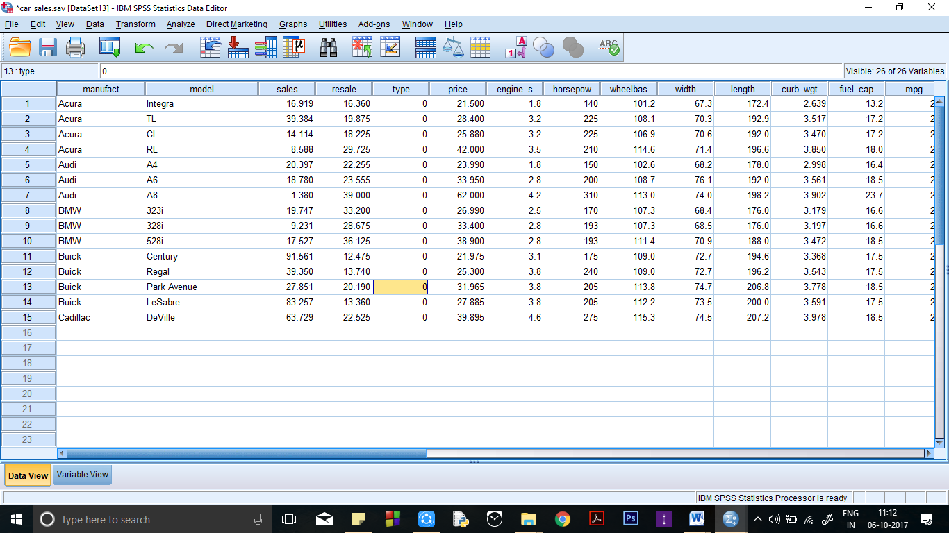

**Data view of input**

**PROCEDURE**:

1. Graphs --> Chart Builder
2. Select and drag the type of graph from the gallery to the Chart Preview.
3. Select and drag the variables accordingly to the Chart Preview. Click on the button saying "Element Properties...". Edit any properties, if required, in the dialog box that opens.
4. Press "Close" when done editing.
5. Press "OK" and the graph is opened in the output window.
6. Do the same for Histogram, Scatter Plot, Box Plot, Bar Graph & Pie Chart.

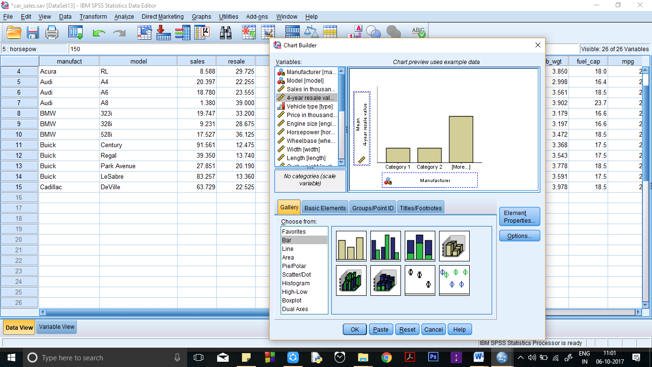

**OUTPUT:**

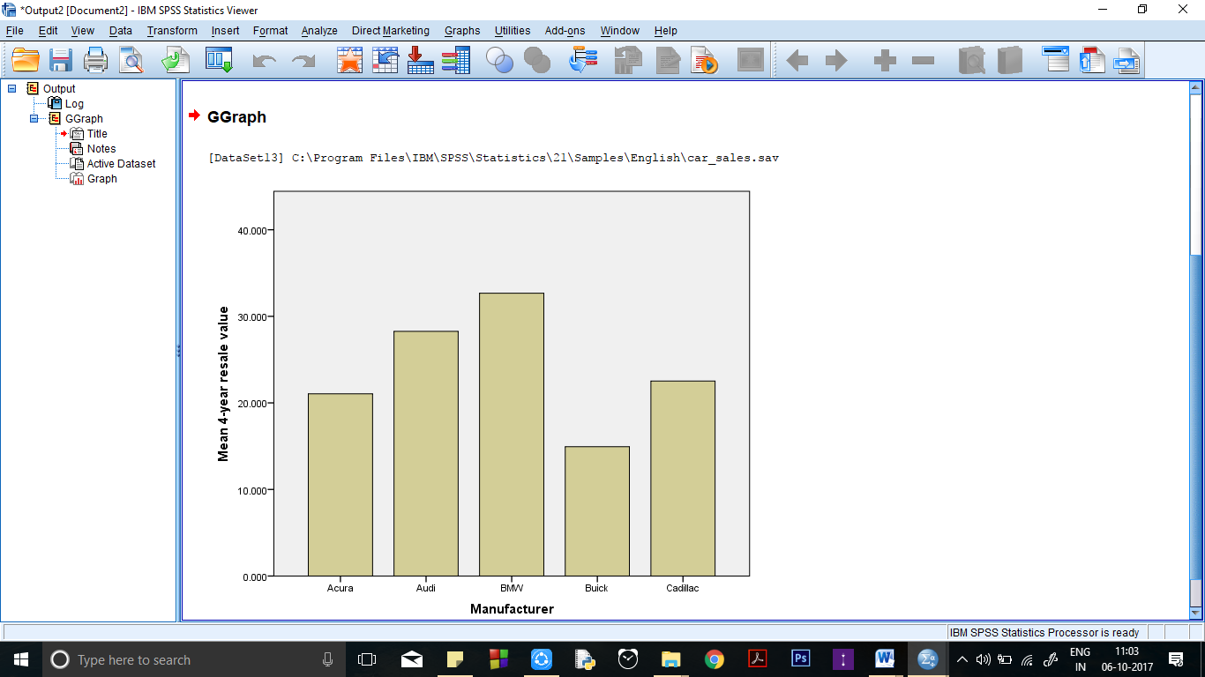

**CLUSTERED BAR:**

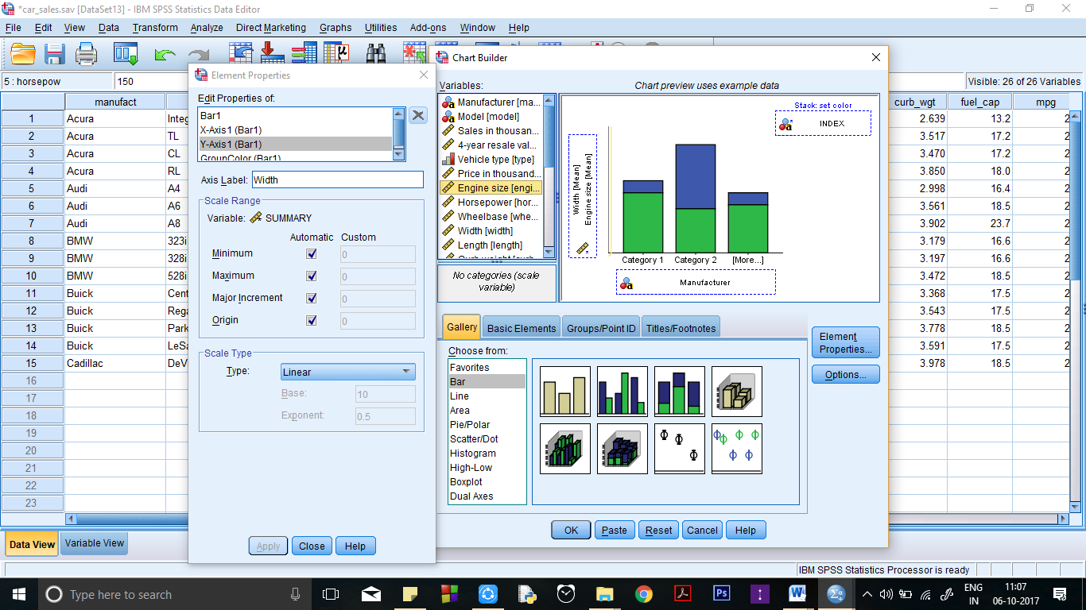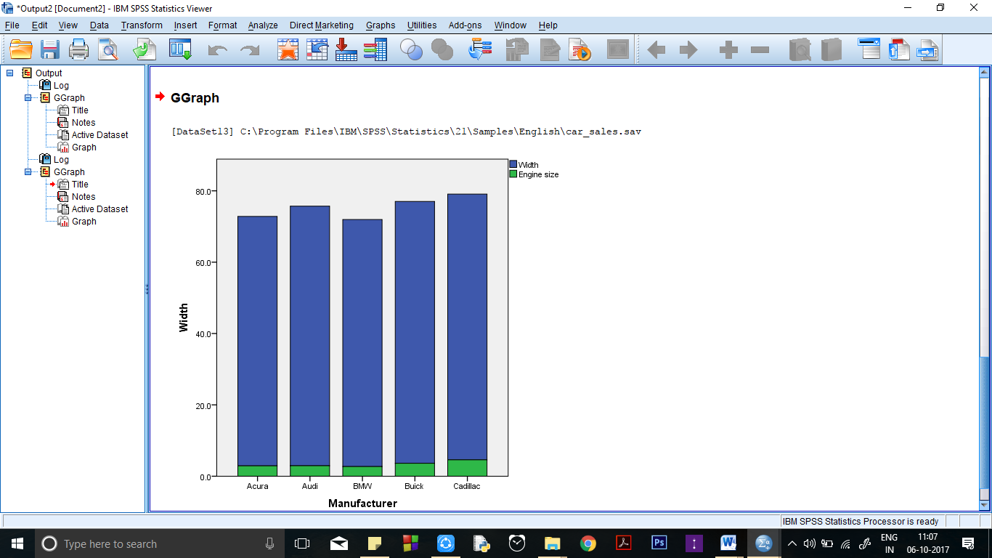

**PIE CHART**

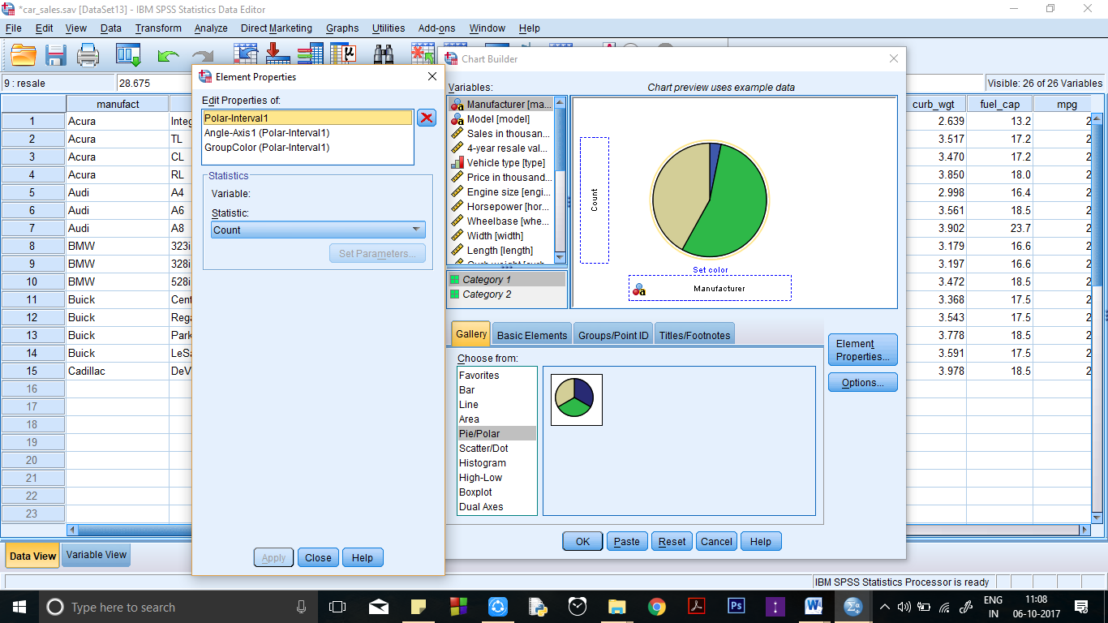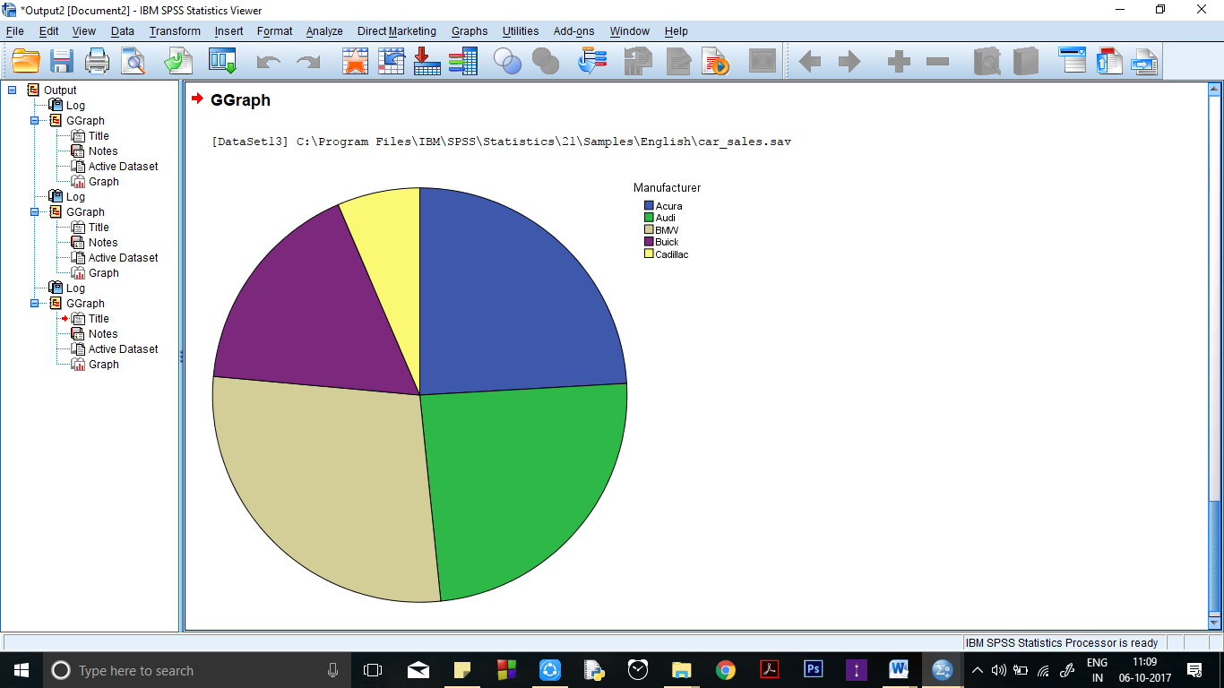

**Scatter PLOT**

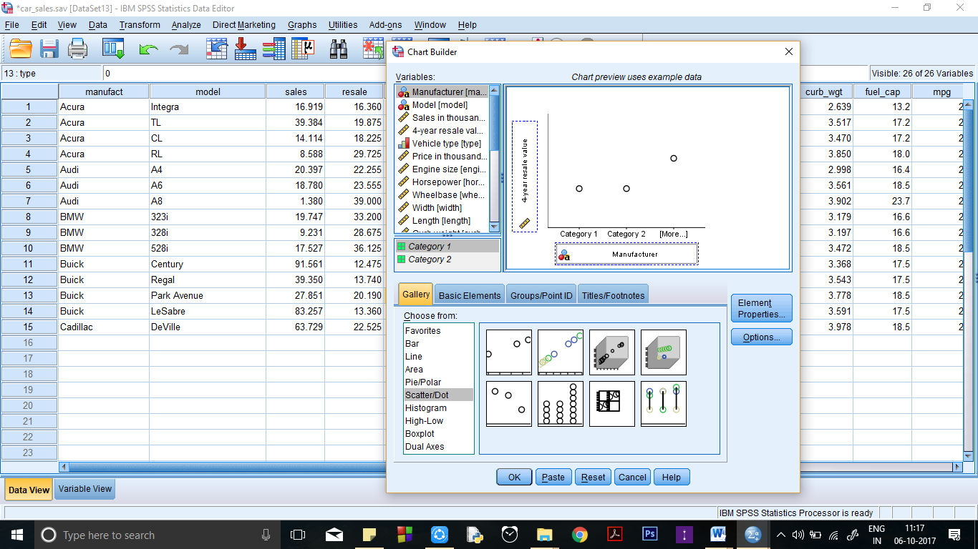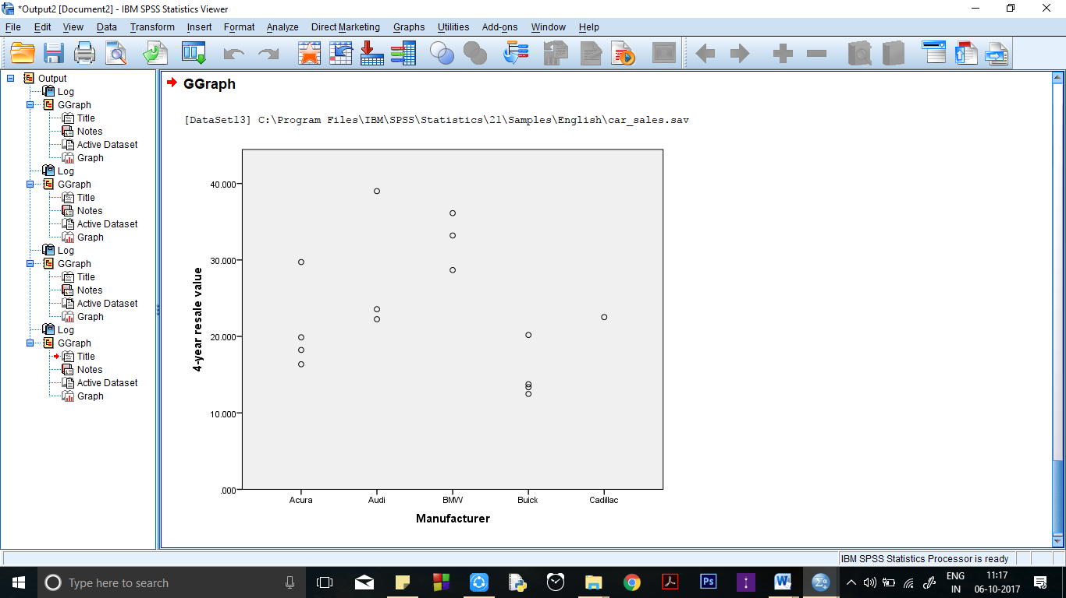

**BOX PLOT**

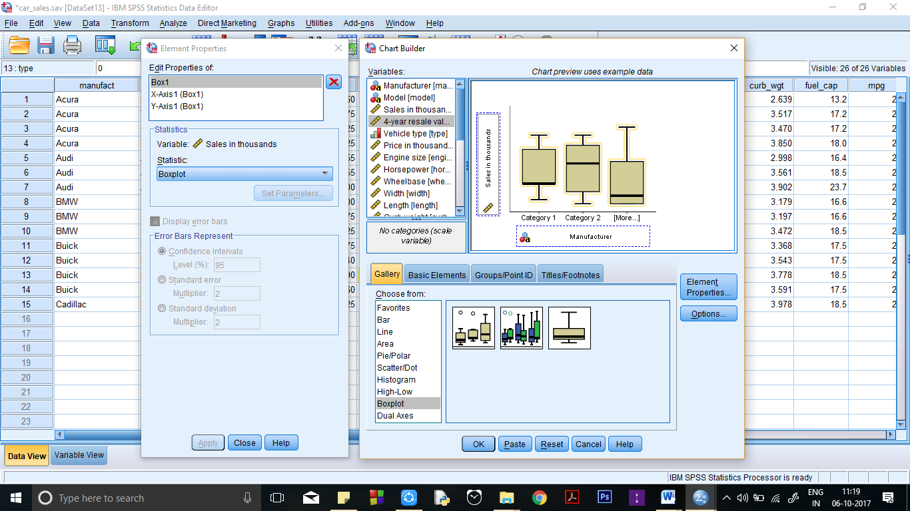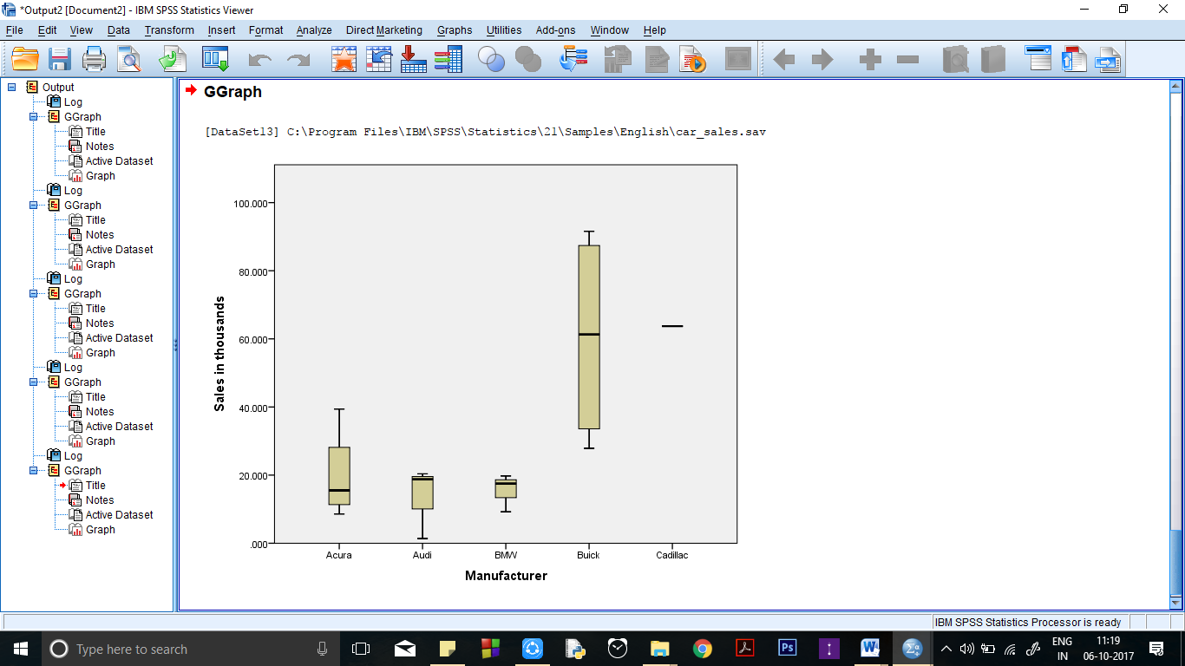

**CONCLUSION:** We conclude that for any given set of data we can represent it easily with

the help of graphs.

**PRECAUTIONS:**

1. Variables should be chosen carefully during plotting of graphs.
2. Graph labels should be chosen appropriately.

**Practical 7**

**Descriptive Statistics of Data.**

**INPUTS and COMMANDS**

Car_Sales.sav ; Commands – Analyze->Descriptive Statistics->Options

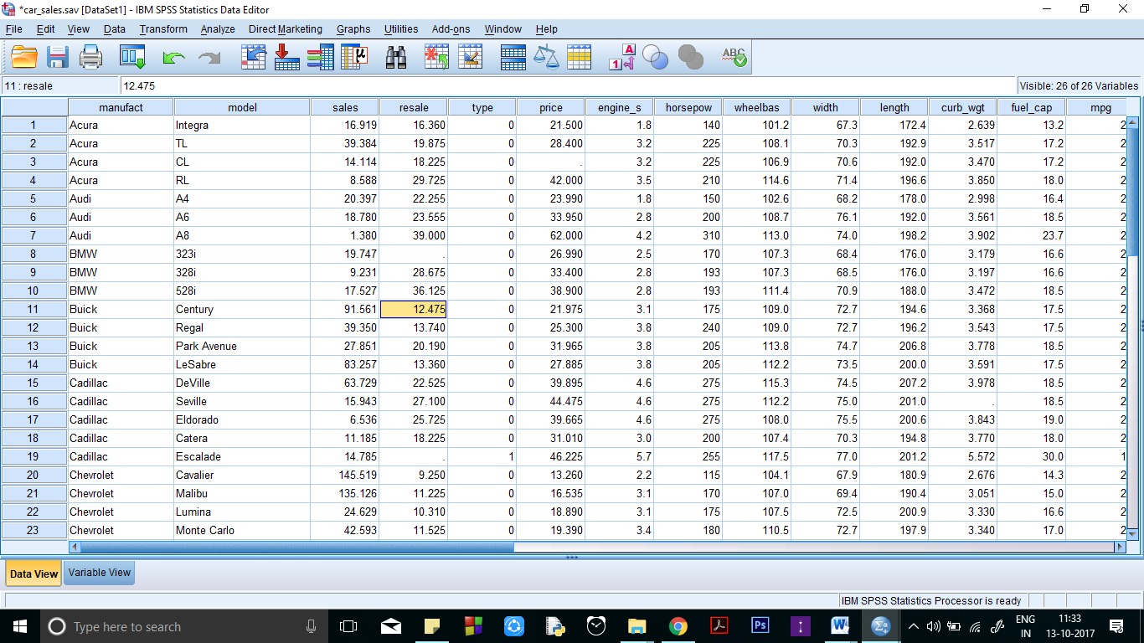

**Data view of input**

**PROCEDURE**:

1. Analyze --> Descriptive Statistics.
2. Select Suitable option on the type of statistics needed.
3. Select the variables for which you want the statistics and put them to the right side of the screen
4. Click the statistics button and choose the suitable parameters as shown.
5. Press “Continue” and then “OK”.
6. Do the same for Frequencies, Descriptive , Explore, etc.

**Frequencies:**

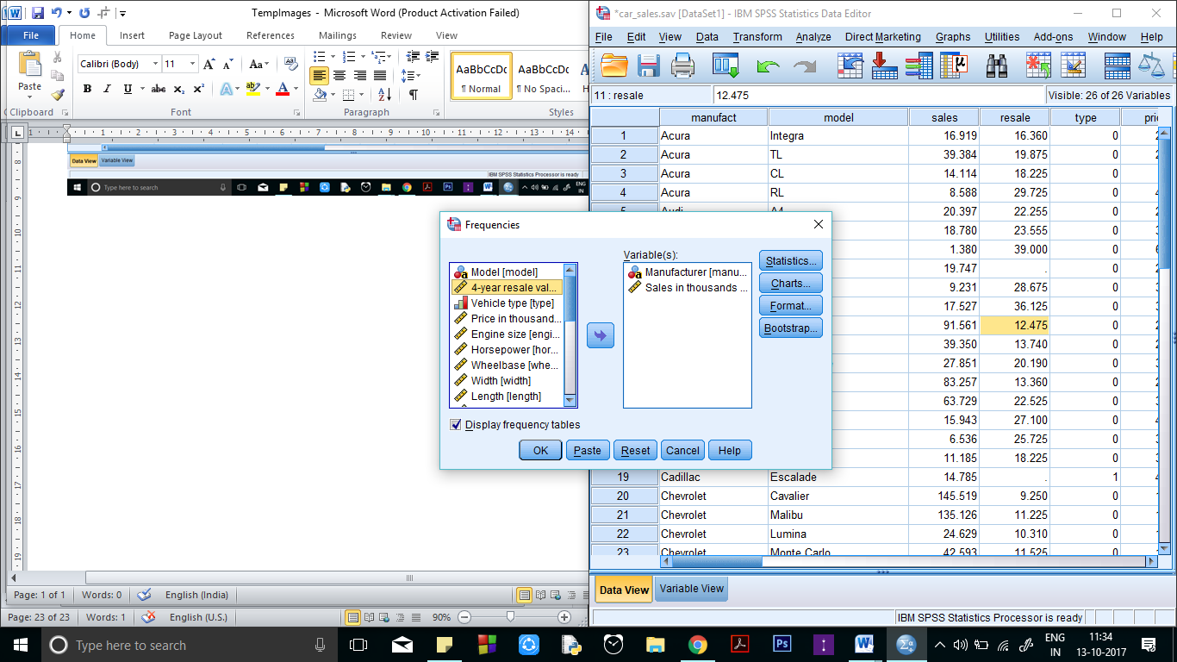 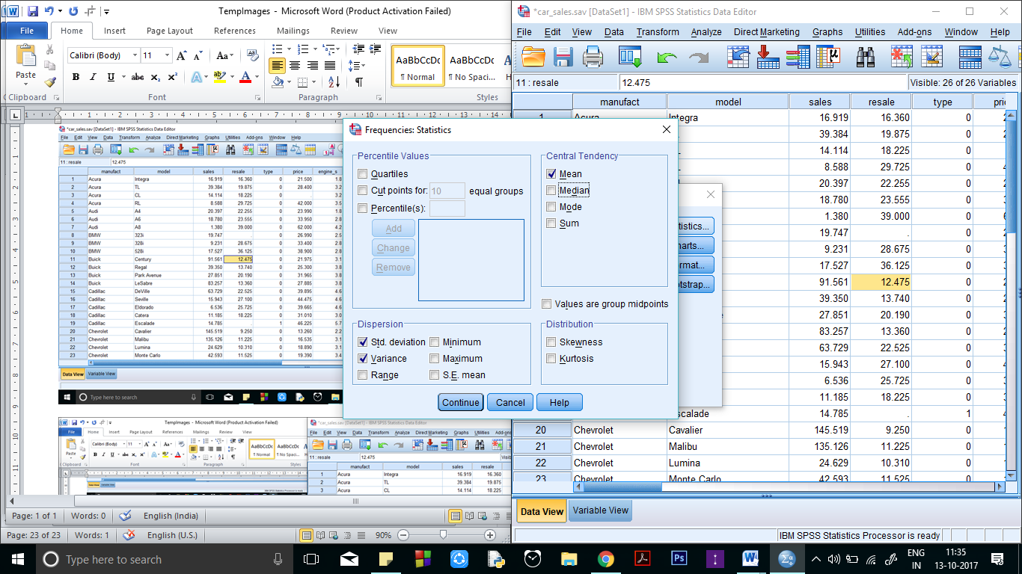

**Output:**

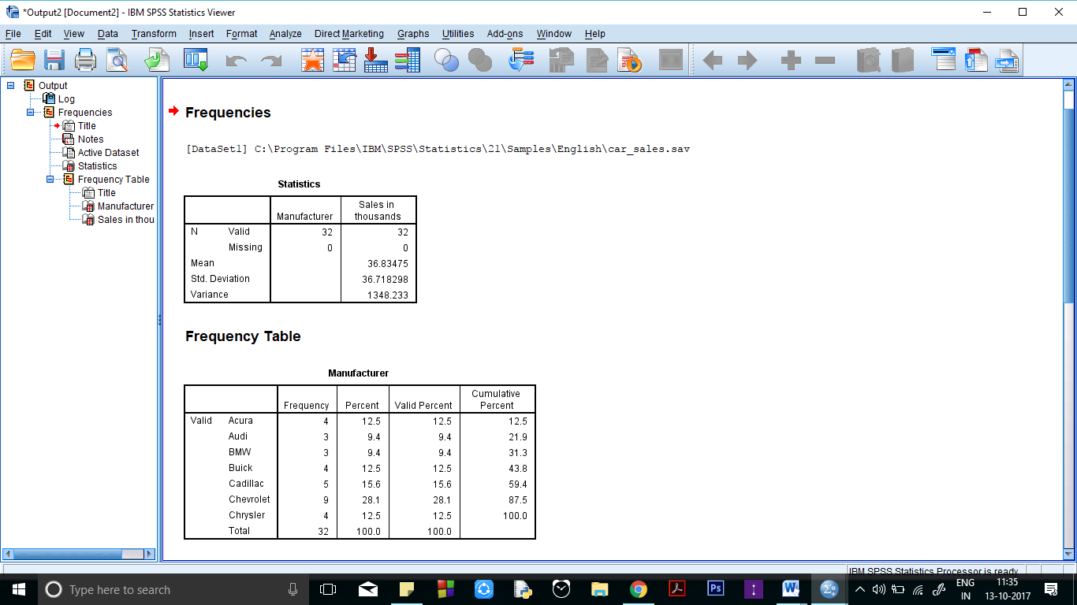

**Descriptive:**

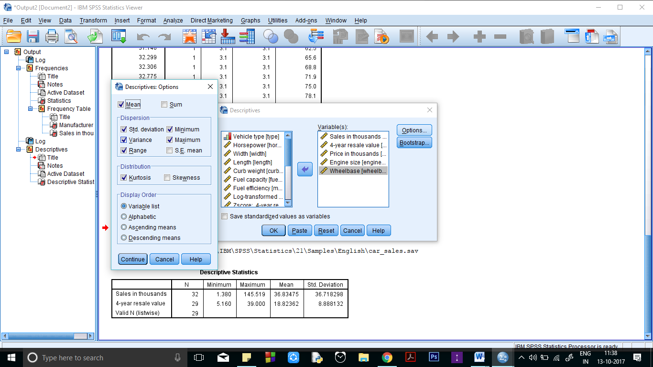 

**Output:**

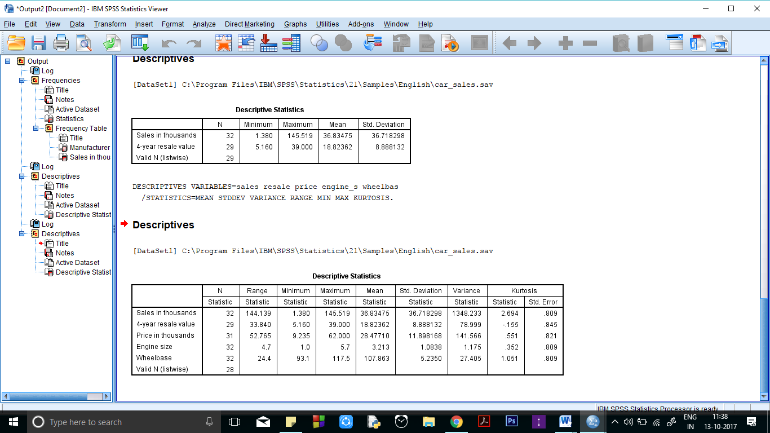

**CONCLUSION:** We conclude that for any given set of data we can represent it easily with

the help of graphs.

**Precautions:**

1. The missing values should be thoroughly checked before applying Descriptive statistics.
2. Before producing output, one must take care of display order.

**Practical 8**

**Regression and Correlation analysis in given data:**

**INPUTS and COMMANDS**

Car_Sales.sav; Commands – Analyze->Regression/Correlate->Options



**Data view of input:**

**PROCEDURE**:

1. Analyze --> Regression/Correlate (select either of the 2).
2. Select Suitable option on the type of statistics needed.
3. Select the variables for which you want the statistics and put them to the right side of the screen
4. Click the options button and choose the suitable parameters as shown.
5. Press “Continue” and then “OK”.
6. Do the same for Regression and correlate as shown below.

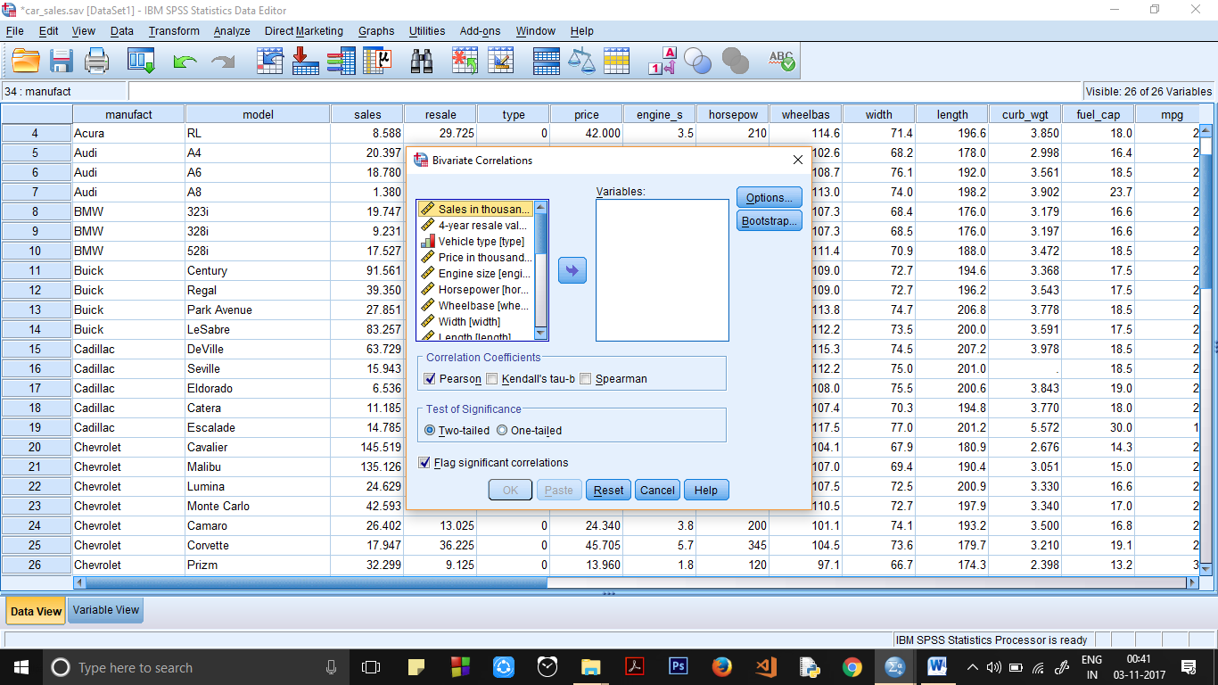 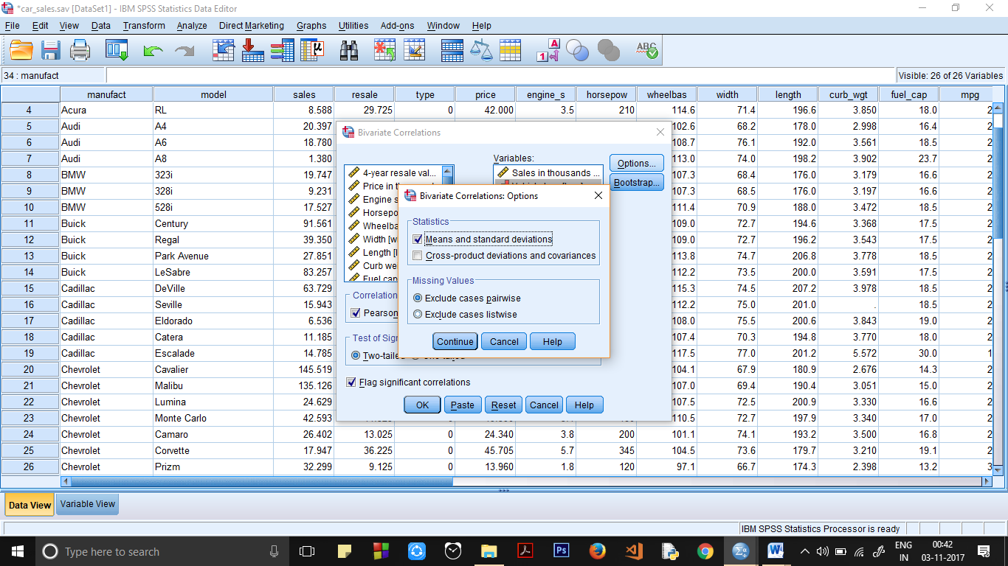

**For Linear Regression:**

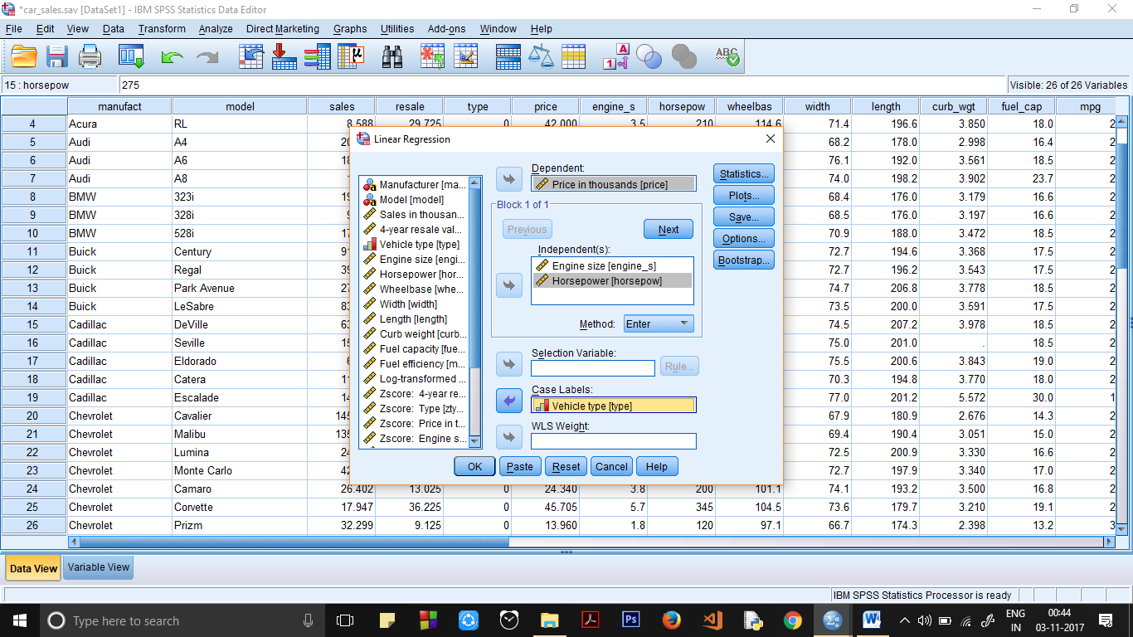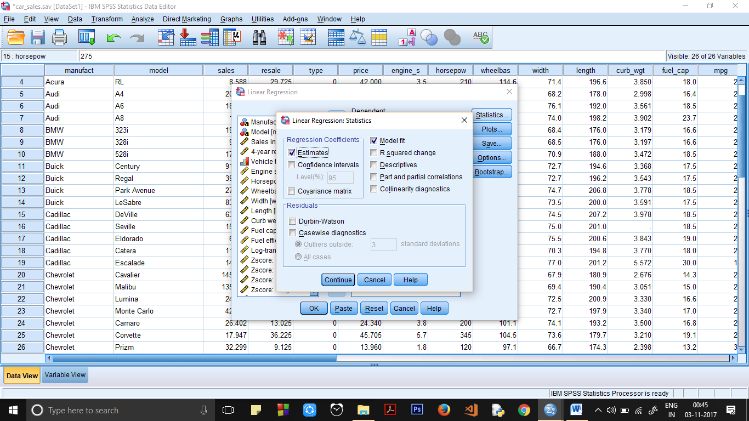

**Output (Correlation)**

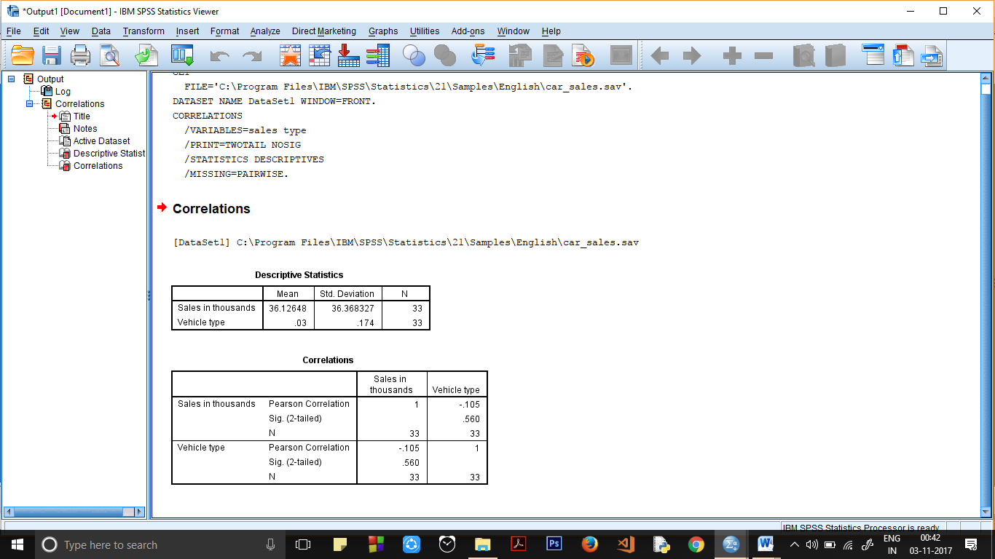

**Output (Linear Regression)**

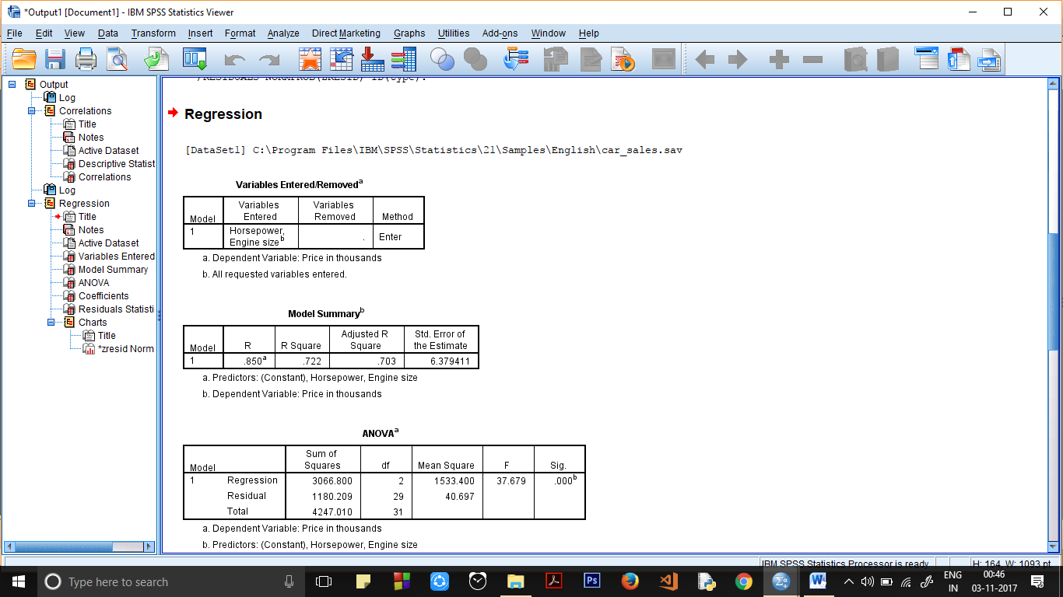

-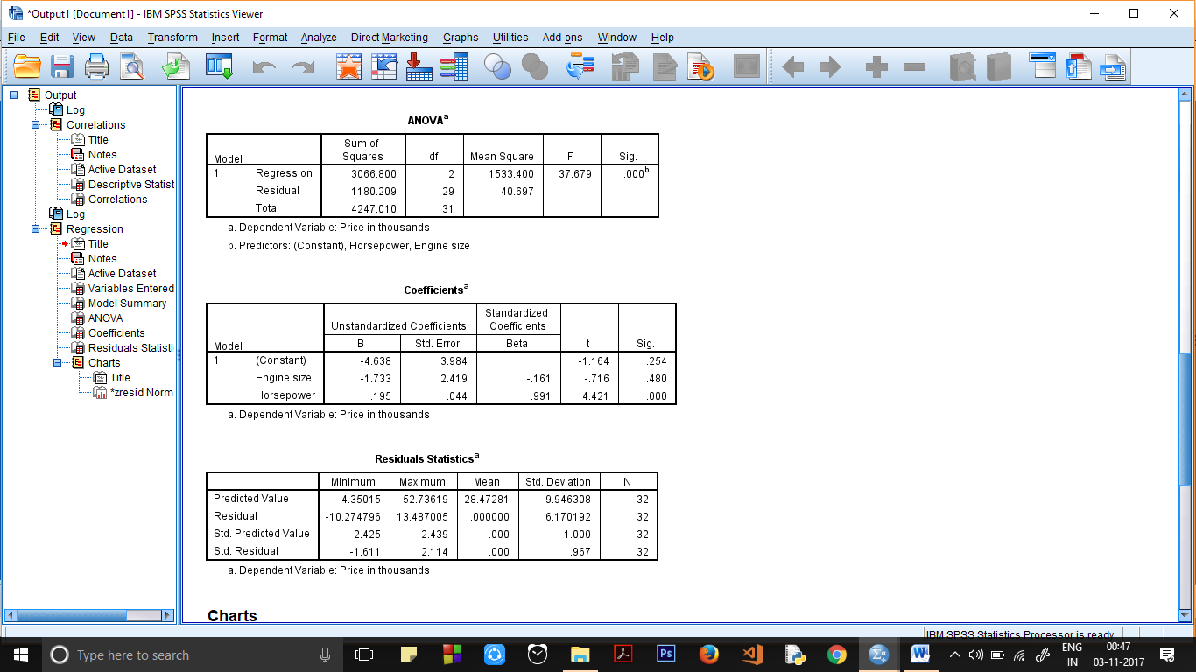

**CONCLUSION:** We conclude that for any given set of data we can easily find a correlation or regression between two or more variables.

**Precautions:**

1. The missing values should be thoroughly checked before applying correlation or regression.
2. Before producing output, one must take care of display order.
3. Large inputs must be avoided since it takes significant computing while calculating regression models.